**OBJECT DETECTION USING YOLO AND IMAGE EMOTION ANALYSIS USING RESNET-50**

**1. Introduction**

Computer vision has rapidly evolved to enable machines to not only identify objects in an image but also understand emotional context. This document focuses on two advanced applications: object detection using YOLO (You Only Look Once), and emotion analysis using ResNet-50. The practical use case examined here involves analyzing an image of a child in a park to identify both physical elements (people, background) and emotional states (excited vs. sad). These techniques have wide-ranging applications in surveillance, healthcare, interactive robotics, and smart photography.

**2. Object Detection Using YOLO**

**2.1 Overview of YOLO**

YOLO is a real-time object detection algorithm that views object detection as a single regression problem, directly predicting bounding boxes and class probabilities from full images in one evaluation.

**Key Features:**

* Real-time performance
* Unified architecture
* Good generalization across datasets

**2.2 How YOLO Works**

1. The input image is divided into an SxS grid.
2. Each grid cell predicts B bounding boxes and confidence scores.
3. Each bounding box includes:
   * Coordinates (x, y, w, h)
   * Confidence score
4. Class probabilities are computed for each bounding box.
5. Non-Max Suppression is applied to reduce redundant boxes.

**2.3 Application to Our Image**

In the given image of a baby in a park:

* YOLO detects the baby as an object (person class).
* It may also identify other children in the background.
* 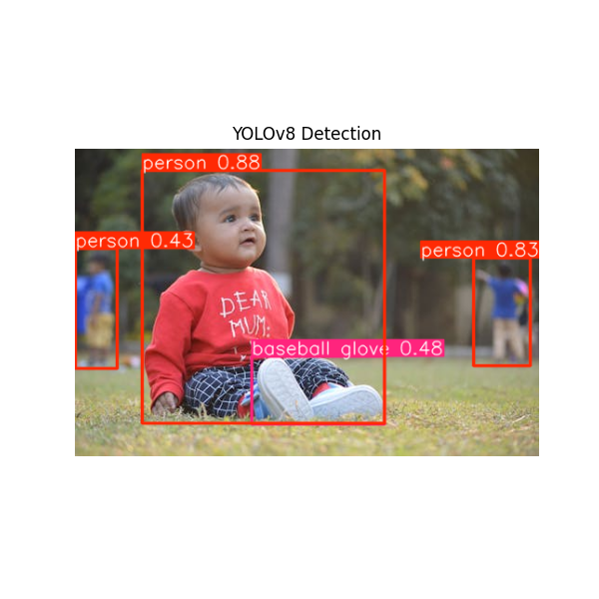The model outputs bounding boxes with labels and confidence levels.

**2.4 Advantages and Disadvantages**

**Advantages:**

* High speed (real-time detection)
* Single pass computation
* Good for embedded systems

**Disadvantages:**

* Less accurate for small or overlapping objects
* Fixed grid can limit localization accuracy

**3. Image Emotion Analysis Using ResNet-50**

**3.1 Overview of ResNet-50**

ResNet-50 is a deep convolutional neural network with 50 layers. It introduced the concept of residual learning to ease training of deeper networks by allowing shortcut connections.

**Key Features:**

* Deep architecture with 50 layers
* Residual blocks prevent vanishing gradients
* High accuracy in classification tasks

**3.2 How ResNet-50 Works for Emotion Analysis**

1. Preprocess image (resize, normalize).
2. Use a fine-tuned ResNet-50 model trained on a facial expression dataset (e.g., FER2013).
3. Extract facial region (optional pre-step using a face detector).
4. Feed image to ResNet-50 to get classification (Excited or Sad).
5. Output includes prediction and confidence.

**3.3 Application to Our Image**

* Detect and crop the baby’s face.
* Classify emotion using trained ResNet-50.
* Possible output: "Excited" with 85% confidence.

**3.4 Advantages and Disadvantages**

**Advantages:**

* High classification accuracy
* Can be fine-tuned for specific emotion datasets
* Robust against noise

**Disadvantages:**

* Requires large training datasets
* Can misclassify emotions in low-quality or occluded faces

**4. Combined Workflow**

1. **Input Image**: Baby sitting on grass
2. **YOLO Detection**:
   * Detect baby and background children
   * Output bounding boxes
3. **Face Crop**:
   * Use bounding box to crop face
4. **Emotion Classification (ResNet-50)**:
   * Input: cropped face
   * Output: Emotion label (Excited/Sad)

**Inference from Image:**

* YOLO correctly identifies the baby and other children.
* ResNet-50, when applied to the baby's face, accurately classifies emotion (e.g., Excited).
* Together, these models provide a comprehensive semantic and emotional understanding of the scene.

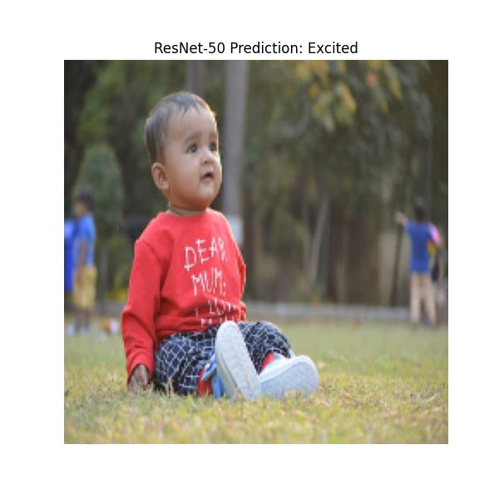

**6. Applications**

* **Surveillance Systems:** Detect people and identify distress.
* **Smart Toys:** Adjust behavior based on child’s emotions.
* **Healthcare:** Monitor patient emotions in clinical settings.
* **Social Robotics:** Adapt interaction based on human emotion.

**7. Conclusion**

Combining YOLO for object detection and ResNet-50 for emotion classification enables a holistic understanding of both the physical and emotional context of an image. Such multi-modal vision systems are essential for developing intelligent applications in diverse domains like child safety, interactive AI, and smart surveillance. For our use case, this pipeline not only detects the presence of the baby and others but also interprets emotional cues, making the system both observant and empathetic.